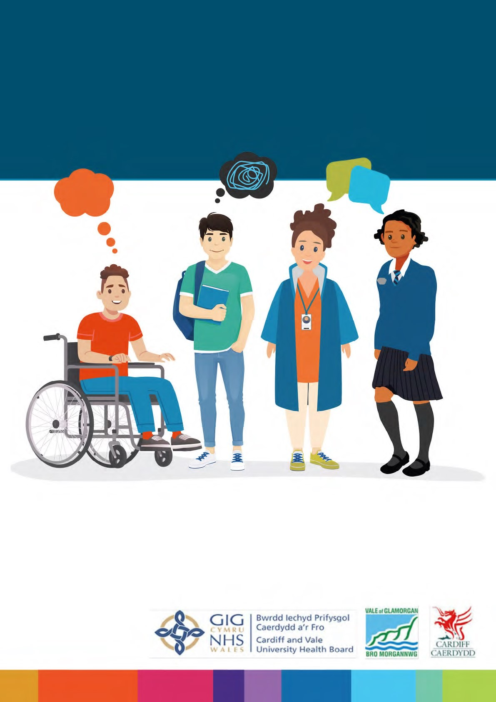

**Planning for your future**

How we will work with children and young people to

support their Transition Plan

This document was written by Cardiff Council, Vale of Glamorgan Council

and Cardiff and the Vale University Health Board. It is an easy read version of

**Planning for My Future. Transition Protocol for Children and Young People**

**aged 14 to 25 with Additional Learning Needs: A Multi- Agency Approach.**

# How to use this document

This is an easy read version. The words and their meaning are easy to read and understand.



You may need support to read and understand this document. Ask someone you know to help you.

Words in **bold blue writing** may be hard to understand. They have been explained in a box below the word.

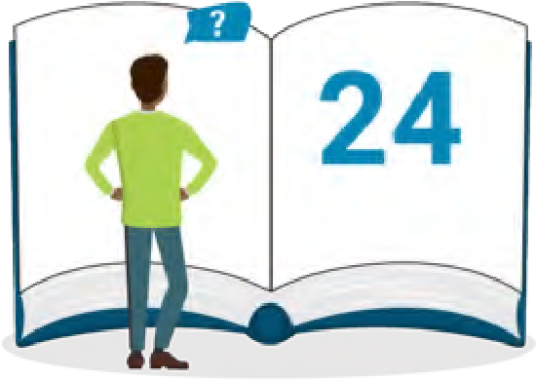

If the hard word is used again it is in normal blue writing. You can check what the words in blue mean on page 24.

Where the document says we, this means Cardiff Council, Vale of Glamorgan Council and Cardiff and the Vale University Health Board.

|  |  |  |
| --- | --- | --- |
| How to use this document |  | 2 |
| About this document |  | 4 |
| Your Rights |  | 5 |
| Planning for your future |  | 8 |
| Transition planning meeting |  | 11 |
| Your transition plan |  | 13 |
| Having an advocate |  | 18 |
| When you need help with making decisions |  | 19 |
| If things go wrong |  | 20 |
| What if I need extra support? |  | 22 |
| Working with you as you grow up |  | 23 |
| Hard words |  | 24 |

# Contents

# About this document

|  |
| --- |
| **Additional Learning Needs** means you have a disability or learning difficulty and need extra support to help you learn. |

|  |
| --- |
| **Transition** is a time in your life when you are growing up and getting ready to leave school, start or leave college and be an adult. |

If you are a child or young person with **additional learning needs**, this document tells you how we will work with you to support planning for your future.

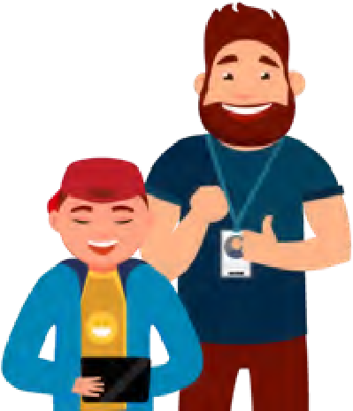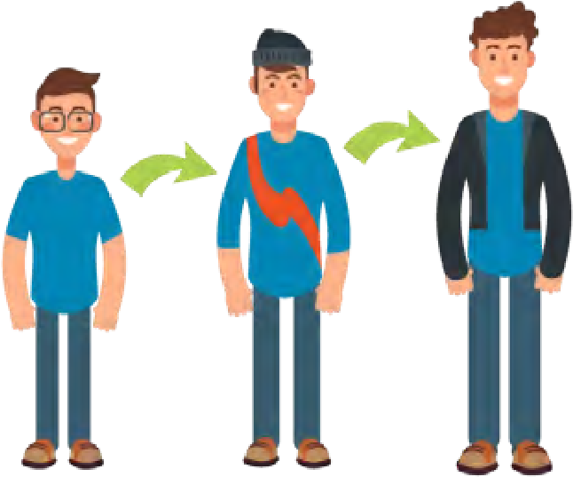

Planning for your future could be in education, training, work or when you become an adult. This is called **transition**.

This document will help you to understand more about planning for your future.

# Your Rights

|  |
| --- |
| **Rights** are the things you are entitled to. There are 52 Rights which are written in the **United**  **Nations Convention on the Rights of the Child**. |

All children and young people have **rights**. We will put your rights at the centre of planning for your future.



**Rights**

The **United Nations convention on the rights of the child (UNCRC)** is a list of rights that all children and young people have, wherever they live in the world.



You can find out more about your rights here:

[gov.wales/childrens-rights-information-children](https://gov.wales/childrens-rights-information-children)

**These are your rights:**

You have the right to be listened to.

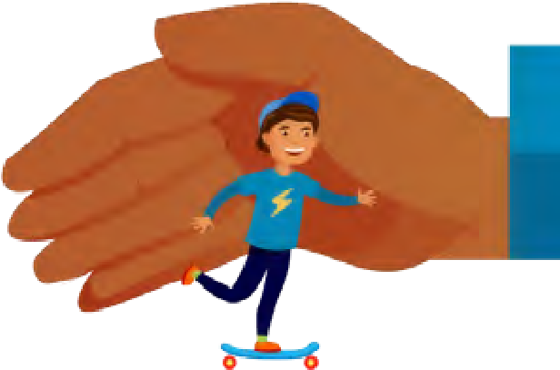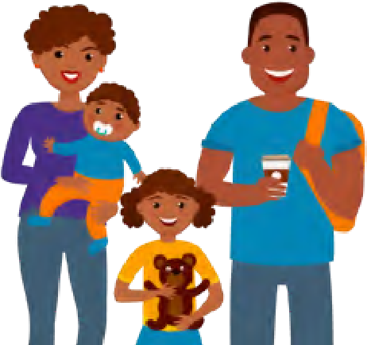

You have the right to be kept safe.

You have the right to enjoy being part of your family, have friends and take part in your community.

If you are 16 years old or more, you have the right to make decisions about your life and be independent.

|  |
| --- |
| **Person Centred Planning** means keeping you at the centre of any plan which is about you and helping you to make a plan. |

Your thoughts, wishes and feelings, including what things are important to you are important to how we work. This is called **person centred planning**.



We will make sure you have information to help you, your family and carers to make choices when you are planning for your future.

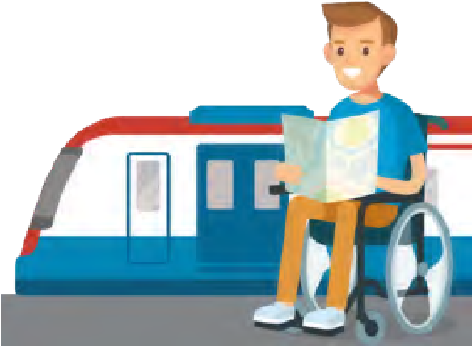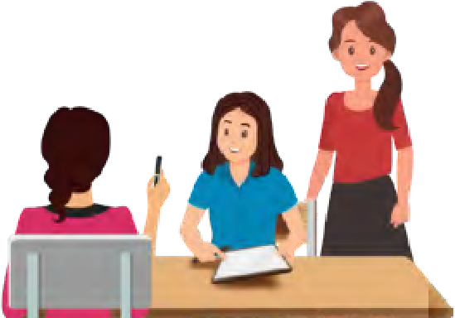

We will listen to you and support you at all times in planning for your future.

We will work together to make sure the right people are involved in decisions to support planning for your future.

We believe that you should be able to use services near to where you live as you grow up.

If you need to use services away from home, we will plan on how to get you the right support when you need it.

# Planning for your future

Planning for your future will start when you are in year 9. This will be in the year you turn14 years old.

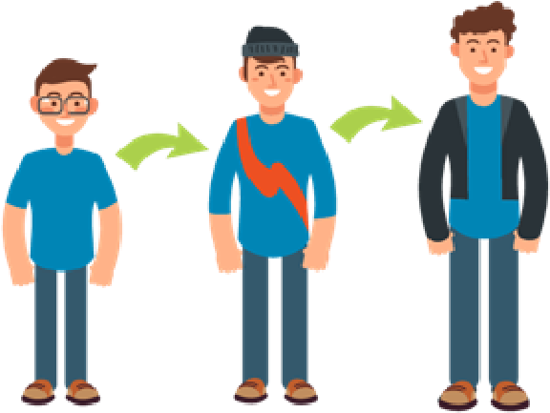

This is called **Transition Planning**

|  |  |  |
| --- | --- | --- |
|  | |  | | --- | | **Transition Planning** is when people get together to help you plan:   * How you want to be supported as you grow up. * And what you want to do when you are older. | |

You are the most important person in planning for your future.

There are other people who will help you plan for your future. These may include:

* your teachers

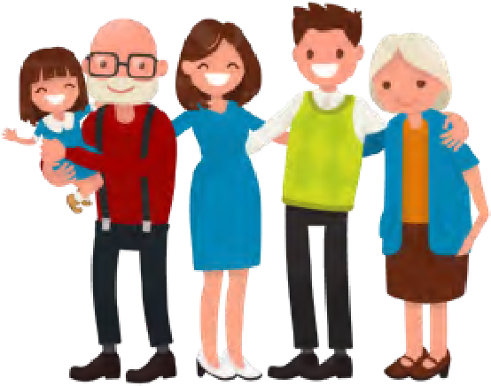

* your family
* a social worker

**Social workers** are people who give extra support to you and your family if you need it. They:

* listen to you and help you to get your voice heard
* help you and your family to make a support plan
* support you and include you in decisions about your life, and find out about what you like to do and what skills you have **●** tell you what help you can get.

|  |
| --- |
| A **healthcare worker** is someone who works in hospitals or community health services like a doctor, a nurse or other people that work in the NHS who provide you with support. |

|  |
| --- |
| **Careers advisers** are people who give information and advice to help people make choices about their education, training and work. |

* a healthcare worker

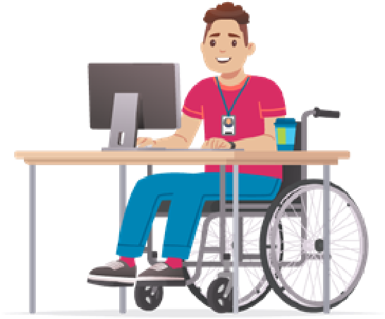

* a **careers adviser**

# Transition planning meeting

In year 9 you will have your first transition planning meeting to help you start to make a **Plan** for your future.

 This meeting may take place in your school

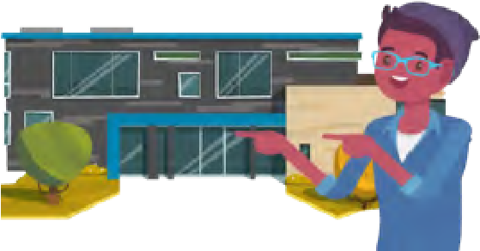 or somewhere else you go to learn.

|  |
| --- |
| **Carers** are the people who you live with and look after you if you do not live with your parents. |

You will be invited to the meeting with your parents or **carers.**

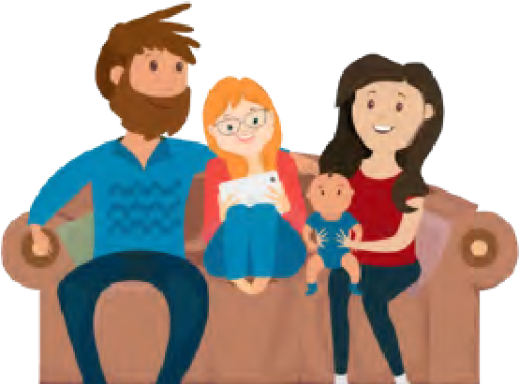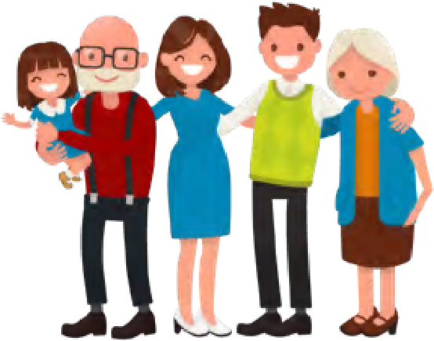

We will invite other people to the meeting who support you now, or who may need to support you as you get older.

If you cannot go to your meeting, we will make sure that we find out what you think. We will use things like your One Page Profile.



At your meeting we will help you make your plan for your future.

# Your transition plan

Your transition plan is a plan for your future. It will be made in a way which is easy for you and your family to understand. It will say:

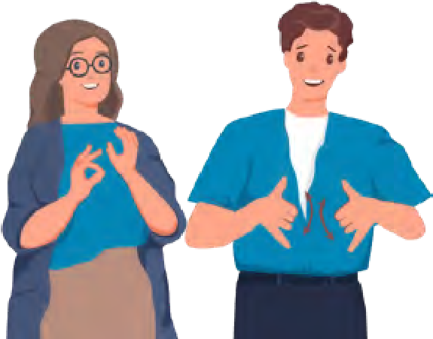

* who you are
* how you prefer to communicate.

**Communicate** means how you tell other people things. Different people **communicate** in different ways like talking, writing, symbols, Makaton, or communication boards.

* information people need to know to support you (One Page profile)

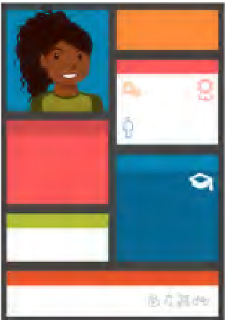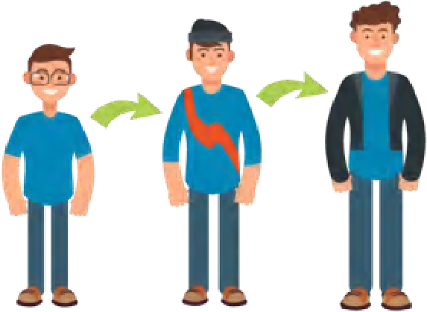

* your wishes and feelings about what you would like to do when you grow up
* how you are going to be supported as you grow up
* who needs to support you

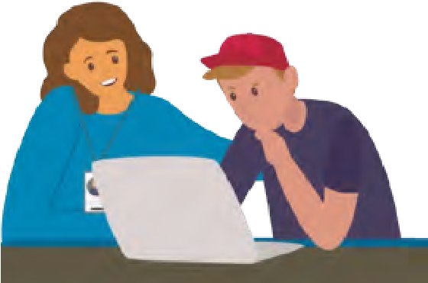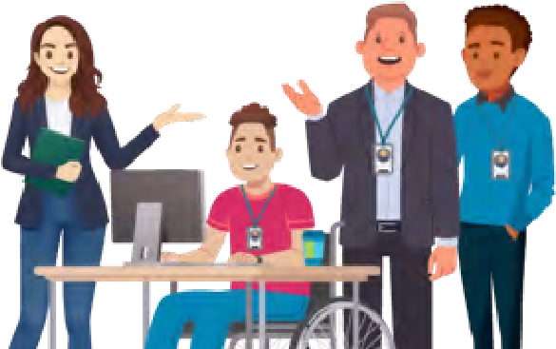

* what people need to do to support you as you grow up

|  |
| --- |
| A **transition key worker** is a person who will make sure your plan runs smoothly and help if there are any problems with it. |

* who your transition key worker is

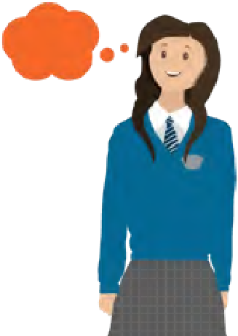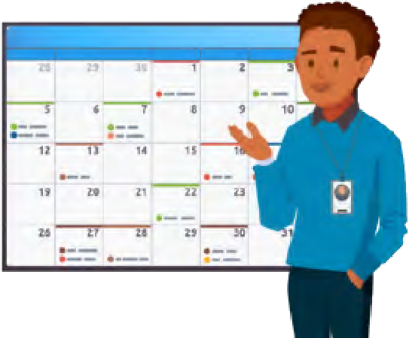

* what you think about your transition plan
* when your transition plan needs to be checked to see if it is helping you and if it needs to be changed
* who you would like to share your transition plan with.

Your transition plan will be used by all the people who support you, like:

* school
* college
* family
* hospital and health services **●** Social services.

Your transition key worker will be someone you can go to if you have any questions about your **Plan**.

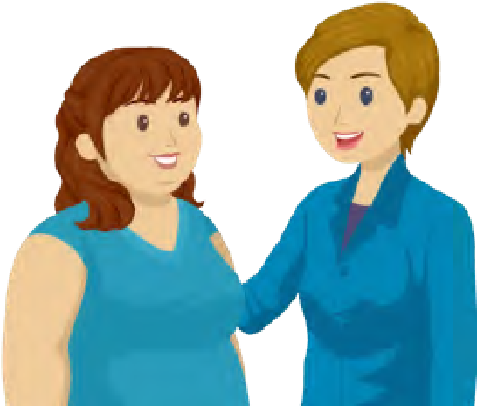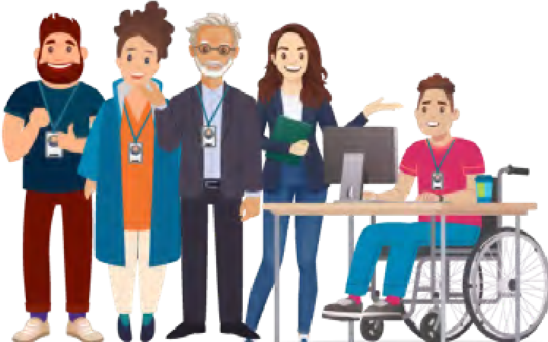

Your transition key worker can be someone from your school, college, health service, social services, or your family.

They will check with you and your family to see if your **Plan** is working.

They can also help you get ready for your planning for your future meetings.

You can have a say in who your transition key worker is.

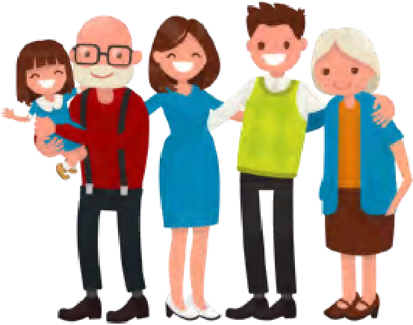

You may have a transition social worker supporting you in planning for your future if you have support from Social Services. They may also be your transition key worker.

If you are under 16 years old, your parents will decide if your transition plan can be shared with other people who work with you and your family.

If you do not live with your parents, social services will decide if your transition plan can be shared.

When you are 16 years old or older you can decide if you still want to have a transition plan and who it can be shared with.

# Having an advocate

|  |
| --- |
| An **advocate** is someone who speaks up for you. They make sure:   * you can say what you think * people listen to you * you are allowed your rights. |

An advocate can help you in transition planning meetings, getting ready for transition planning meetings and with other decisions you make during transition.

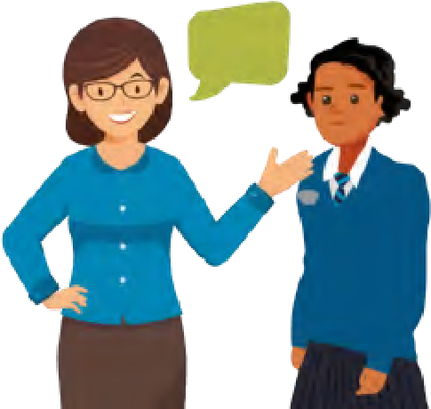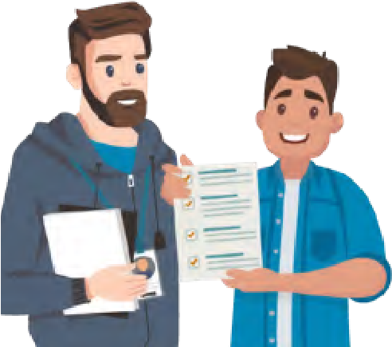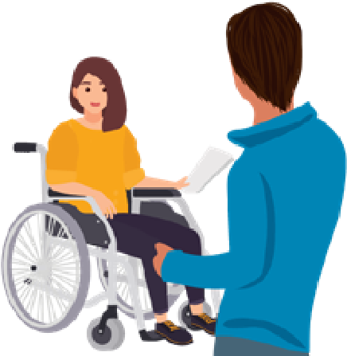

If you want an advocate you can ask your school or college for one. If you have a social worker you can also ask them for an advocate.

If someone else thinks that having an advocate will be good for you, they will tell you to make sure that you can have an advocate if you want to.

# When you need help with making decisions

|  |
| --- |
| A **Case Friend** or a **Representative** is someone who can:   * speak up for you * help you understand what is happening **●** make good decisions for you. |

If you cannot understand enough to make decisions during your transition, we will help you say what your feelings and wishes are.

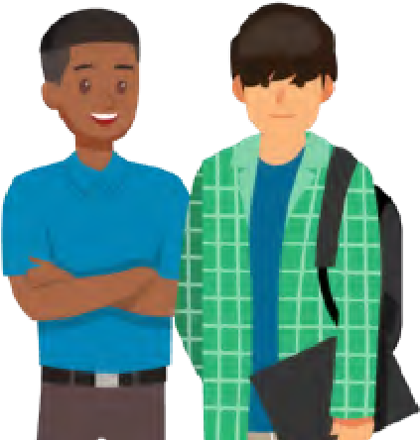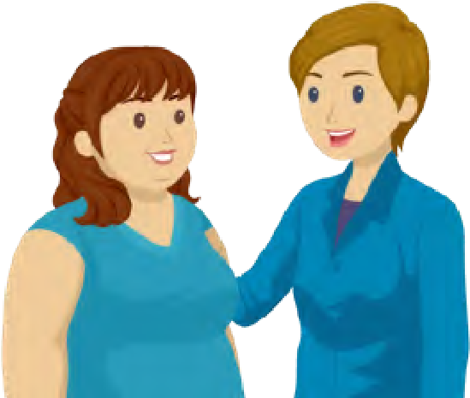

We will make sure that you have a **Case Friend** or a **Representative** if you need one.

# If things go wrong

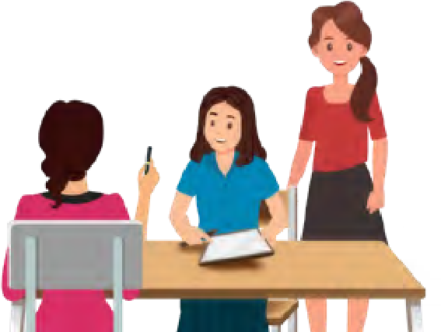We will make sure that you have help at your transition planning meetings. You can talk about your worries and get your questions answered so we can sort things out quickly.

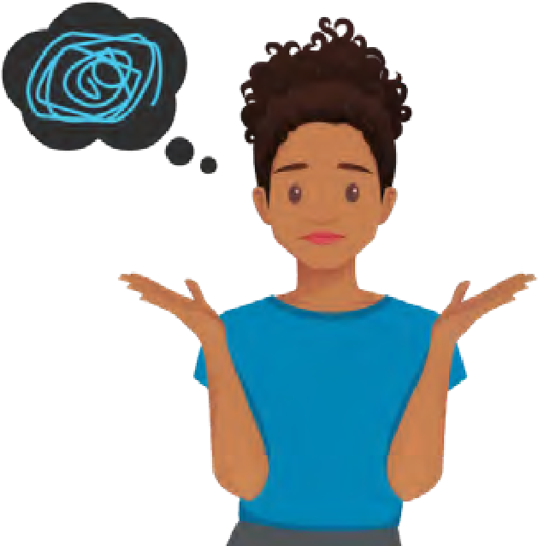If you are not happy with your transition plan or with someone who is working with you on your transition plan you can speak to:

* your social worker
* your teacher
* your advocate
* your healthcare worker
* your transition key worker.

|  |
| --- |
| The **Disagreement Resolution Service** are people who can help others sort out things they do not agree about. |

If you are still not happy or want to speak with someone else, there are other people who can help you. These people belong to the **Disagreement Resolution Service** and we will make sure you know who they are and how they can help you.



You can also make a complaint if you are not happy about your plan or someone that is working with you on it. We will make sure you know how to do this and where to send your complaint to.

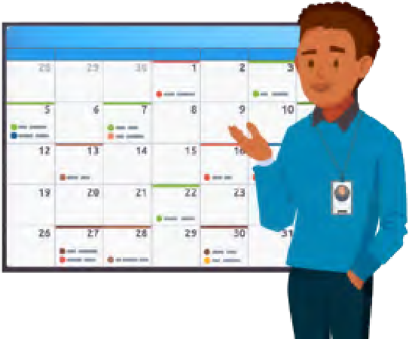

Yourtransition plan will be checked at least once a year to see if it is right and if anything needs to be changed.

Each meeting to check your plan will be like your first transition planning meeting.

Everyone working with you will get a chance to:

* see if your transition plan has helped you
* work with you to make changes to the **Plan** if needed.

**What if I need extra support?**

|  |
| --- |
| **Multi agency** means different services like health, social services and education working together as a team to give you the support you need. |

Your transition plan may show that you need support from a transition social worker who can help you in planning for your future.

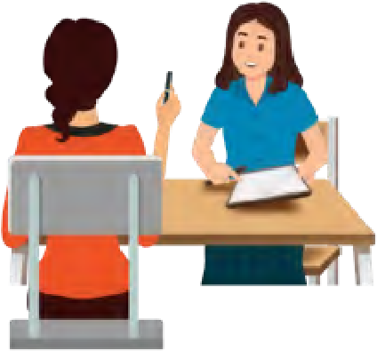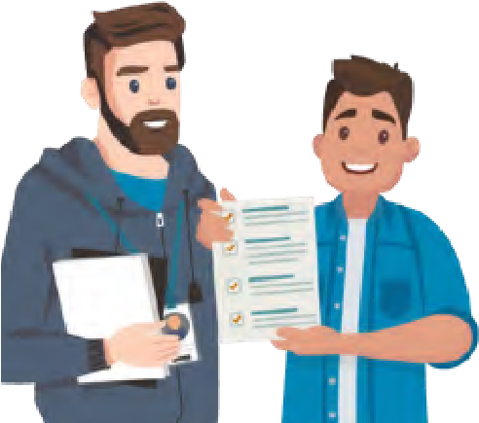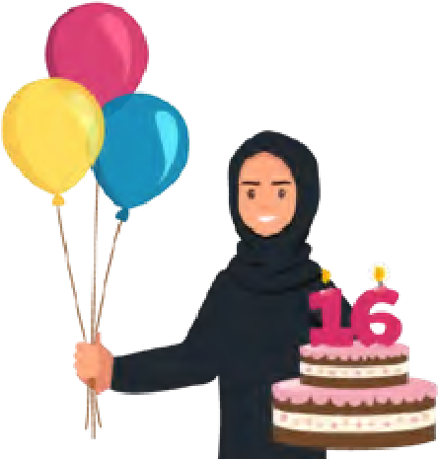

We will always ask your permission before we ask for their help.

If your transition social worker thinks you may need ongoing support as you become an adult they will:

* ask for a **multi-agency** decision on who will continue to help you plan for your future when you are 18years old
* If you need an adult social worker they will start working with you from year 11. This is the year you will turn 16 years old

# Working with you as you grow up

Each time we check to see if your transition plan is working, we will celebrate how things have worked for you, and what still needs to be planned.

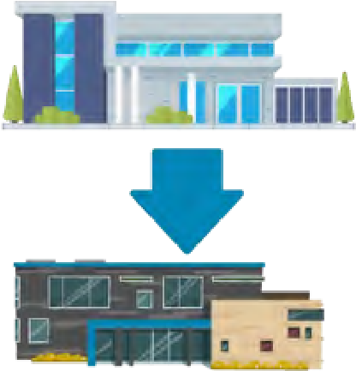

This plan may include having an adult social worker instead of a transition social worker.

Or the plan may also include leaving school and starting college.

We will make sure your plan is right for you every year as things change for you.

We will stop planning for your future when you:

* ask us to
* leave education and don’t need any other help in planning for your future.

# Hard words

## Additional Learning Needs

Additional Learning Needs means you have a disability or learning difficulty and need extra support to help you learn.

## Advocate

An Advocate is someone who makes sure:

* you can say what you think
* people listen to you
* you are allowed your rights

## Carers

Carers are the people who you live with and look after you if you do not live with your parents.

## Careers Advisers

Careers advisers are people who give information and advice to help people make choices about their education, training and work.

## Case Friend

A Case Friend is someone who

* speaks up for you
* help you understand what is happening
* make good decisions for you.

## Communicate

Communicate means how you tell other people things. Different people communicate in different ways like talking, writing, symbols, Makaton, or communication boards.

**Disagreement Resolution Service**

These are people who can help others sort out things they do not agree about.

## Healthcare Worker

A healthcare worker is someone who works in hospitals or health services like a doctor or a nurse. They help people who need health care and support.

## Multi Agency

Multi agency means services like health, social services and education working together as a team to give you the support you need.

## Person Centred Planning

Person Centred Planning means helping you to make a plan by keeping you at the centre of any plan which is about you.

## Rights

Rights are the things you are entitled to. There are 52 Rights which are written in the United Nations Convention on the Rights of the Child.

## Social workers

Social workers are people who give extra support to you and your family if you need it. They:

* listen to you and help you to get your voice heard **●** help you and your family to make a support plan.
* support you and include you in decisions about your life, and find out about what you like to do and what skills you have **●** tell you what help you can get.

## Transition

Transition is a time in your life when you are growing up and getting ready to leave school, start or leave college and be an adult.

## Transition Key Worker

A transition key worker is a person who will make sure your plan runs smoothly and help if there are any problems with it.

## Transition Planning

Transition Planning is when people get together to help you plan: **●** how you want to be supported as you grow up **●** what you want to do when you are older.